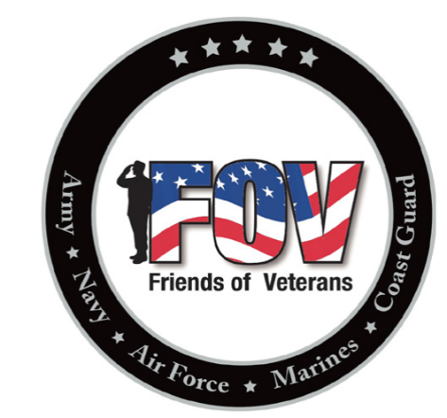
4th Annual
Friends of Veterans
Charity Golf TOURNAMENT
August 15, 2020
Hole Sponsorship
Emerald Greens Golf Course
Hastings, MN
HOLE SPONSORSHIP FORM – Turn into Friends of Veterans member or the bartender at the Rosemount VFW Post 9433 along with $100 (cash or check) sponsorship fee.
Please print clearly.
Sponsor Name
Sponsor Company / Organization Name (optional)
Sponsor Phone Number
Sponsor Email Address
Sponsor Address
Comments

Make checks payable to: Friends of Veterans
Friends of Veterans
2625 – 120th Street West
Rosemount, MN 55068

Thank you for your support!

