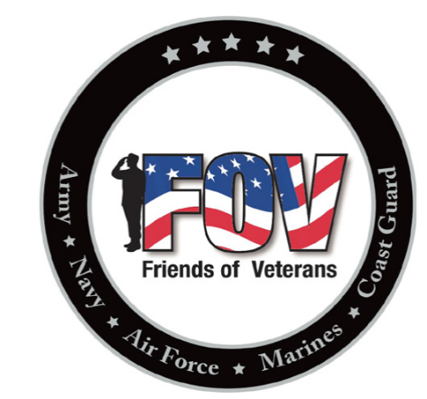
4th Annual
Friends of Veterans
Charity Golf TOURNAMENT
September 19, 2020
Emerald Greens Golf Course
Hastings, MN

SIGN UP FORM – Turn into Friends of Veterans member or the bartender at the Rosemount VFW Post 9433 along with $300 (cash or check) team entry fee.
Due to the COVID-19 Pandemic, teams will be limited to the first 25 teams that sign up and pay. Check-in will be limited to the team captains only. Social distancing and limited contact with other teams may be necessary. There are a lot of unknowns.
Please print clearly.
Team Name
Team Contact – Name and Phone Number
Player #1 Name
Player #2 Name
Player #3 Name
Player #4 Name

Make checks payable to: Friends of Veterans
Friends of Veterans
2625 – 120th Street West
Rosemount, MN 55068

Thank you for your support!

